# PROJECT REPORT

A GESTURE-BASEDTOOL FOR STERILE BROWSING OF RADIOLOGY IMAGES

**Team Id :** PNT2022TMID17537

**Team Leader :** S.THILAK - 2019108057

**Team Member :** C.PRAVEEN - 2019108040

**Team Member :** Y.RAM KUMAR - 2019108045

**Team Member :** M.PRASANNA KASI - 2019108039

CONTENT

# INTRODUCTION

* 1. Project Overview

# LITERATURE SURVEY

* + 1. Existing problem
    2. References
    3. Problem Statement Definition

# IDEATION & PROPOSED SOLUTION

* + 1. Empathy Map Canvas
    2. Ideation & Brainstorming
    3. Proposed Solution
    4. Problem Solution fit

# REQUIREMENT ANALYSIS

* + 1. Functional requirement
    2. Non-Functional requirements

# PROJECT DESIGN

* + 1. Data Flow Diagrams
    2. Solution & Technical Architecture
    3. User Stories

# PROJECT PLANNING & SCHEDULING

* + 1. Sprint Planning & Estimation
    2. Sprint Delivery Schedule
    3. Reports from JIRA

# CODING & SOLUTIONING (Explain the features added in the project along with code)

* + 1. Feature 1
    2. Feature 2

# TESTING

* + 1. Test Cases
    2. User Acceptance Testing

# RESULTS

* + 1. Performance Metrics 2.Output

# ADVANTAGES & DISADVANTAGES

* 1. **CONCLUSION**

# FUTURE SCOPE

* 1. **APPENDIX**
     1. Source Code
     2. GitHub & Project Demo Link

# INTRODUCTION

* 1. **PROJECT OVERVIEW:**
     + Intuitive show frameworks utilize progressed Human PC Cooperation (HCI) procedures to give a more helpful and easy to use interface for controlling show shows, for example, page up/down controls of x-beams and transferred pictures in the clinical field machine console control, new experience is altogether improved with these methods.
     + Hand signal has colossal applications. In this review, we apply it to an intuitive show framework to make a straightforward cooperation interface.
     + The utilization of specialist PC cooperation gadgets in the activity room (OR) requires new modalities that help clinical imaging control while permitting specialists' hands to stay clean. We are introducing "Gestix," a dream based hand signal catch and acknowledgment framework that deciphers progressively the client's motions for route and control of pictures in an electronic clinical record (EMR) data set.
     + "Gestix" was tried during a cerebrum biopsy methodology. In the in vivo explore, this connection point forestalled the specialist's center shift and change of area while accomplishing a fast natural response and simple collaboration.

# LITERATURE SURVEY :

* 1. Existing Problem:
* A significant test included is to give Specialists effective, instinctive, exact and safe method for collaboration without influencing the nature of their work.
* Anyway the utilization of PC consoles and mouse by specialists in serious consideration unit(ICU) is a typical mean for spreading contaminations.
* We recommend the utilization of hand motions in clinical field as an option in contrast to the current connection point methods by offering greatest degree of sterility.
  1. References
     + Robust Part-Based Hand Gesture Recognition Using Kinect SensorZhou Ren,Junsong Yuan, Member, IEEE, Jingjing Meng, Member, IEEE, and Zhengyou Zhang, Fellow, IEEE, 15, AUGUST 2013.
     + A Fast Gesture Recognition Scheme for Real-Time HumanMachine Interaction Systems . Ching-Hao Lai* Smart Network System Institute forInformation Industry Taipei City, Taiwan , 2010.
     + Intension, Context and Gesture Recognition for Sterile MRI Navigation in theOperating Room by Agency for Healthcare Research and Quality (AHRQ)
     + Hand Gestures Recognition Using Radar Sensors for

Human-ComputerInteraction Supported by the Bio ad Medical TechnologyDevelopment Program of the National Research Foundation(NRF).A Preliminary Study of Kinect-Based Real-Time Hand Gesture Interaction Systems for Touchless Visualizations of Hepatic Structures in Surgery by Medical Imaging and Information Sciences, Jiaqing LIU, Tomoko Tateyama

* 1. Problem Statement Definition

A significant test included is to furnish Specialists with proficient, instinctive, precise and safe method for cooperation without influencing the nature of their work. Anyway the utilization of PC consoles and mouse by specialists in concentrated care unit(ICU) is a typical mean for spreading infections.We propose the utilization of hand signals in clinical field as an option in contrast to the current connection point strategies by offering most extreme degree of sterility.

# IDEATION & PROPOSED SOLUTION :

* 1. Empathy Map Canvas

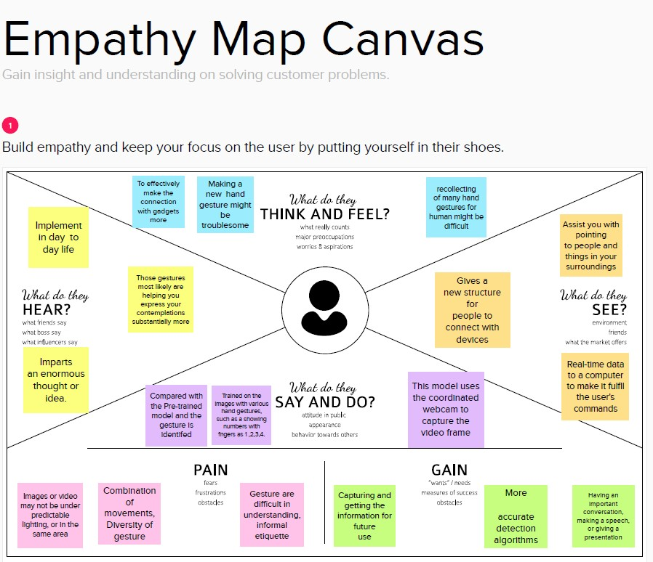

#### Ideation & Brainstorming

Conceptualizing gives a free and open climate that empowers everybody inside a group to partake in the imaginative reasoning cycle that prompts critical thinking. Focusing on volume over esteem, out-of-the- container thoughts are gladly received and based upon, and all members are urged to team up, helping each other foster a rich measure of clever fixes.

**Step-1:** Team Gathering, Collaboration and Select the Problem Statement.

**Step-2:** Brainstorm, Idea Listing and Grouping.

**Step-3:** Idea Prioritization.

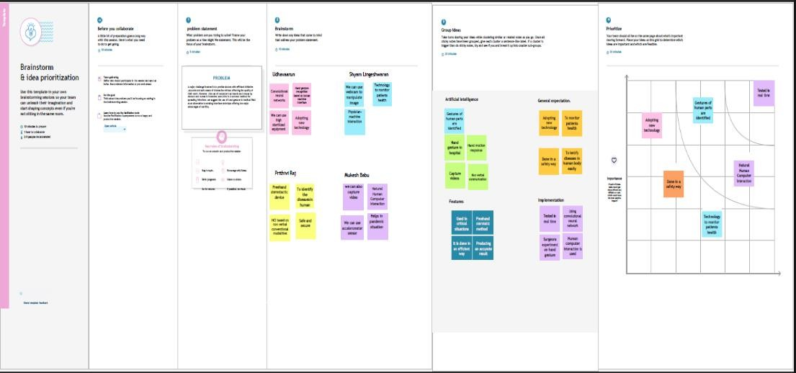

#### Proposed Solution

The collaboration with interventional imaging frameworks inside a sterile climate is a difficult errand for doctors. Direct doctor machine connection during a mediation is somewhat restricted as a result of sterility and work area limitations.

* We propose a strategy for motion controlled projection show that empowers an immediate and regular doctor machine collaboration during registered tomography (CT)- based intercessions.
* Consequently, a graphical UI is projected on a radiation safeguard situated before the doctor. Hand signals before this show are caught and characterized utilizing a jump movement regulator.
* We propose a motion set to control essential elements of mediation programming like signals for 2D picture investigation, 3D item control and choice. Our strategies were assessed in a clinically situated client study with 12 members

The consequences of the performed client study affirm that the presentation and the hidden communication idea are acknowledged by clinical clients. The acknowledgment of the motions is vigorous, in spite of the fact that there is potential for upgrades.

* The signal preparation times are under 10 min, however shift intensely between the members of the review. The created signals are associated intelligently to the intercession programming and instinctive to utilize.
* The proposed signal controlled projection show counters current reasoning, to be specific it gives the radiologist unlimited authority of the mediation programming. It opens additional opportunities for direct doctor machine collaboration mediations in particular during medical procedures.

# Problem Solution Fit

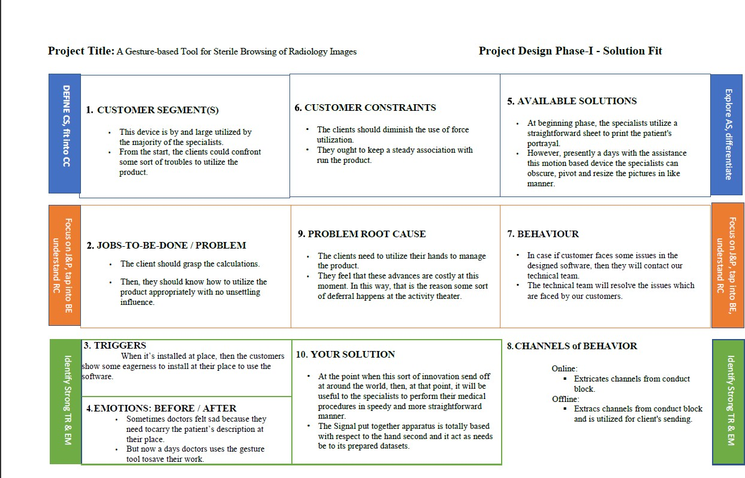

#### REQUIREMENT ANALYSIS :

* 1. Functional Requirements

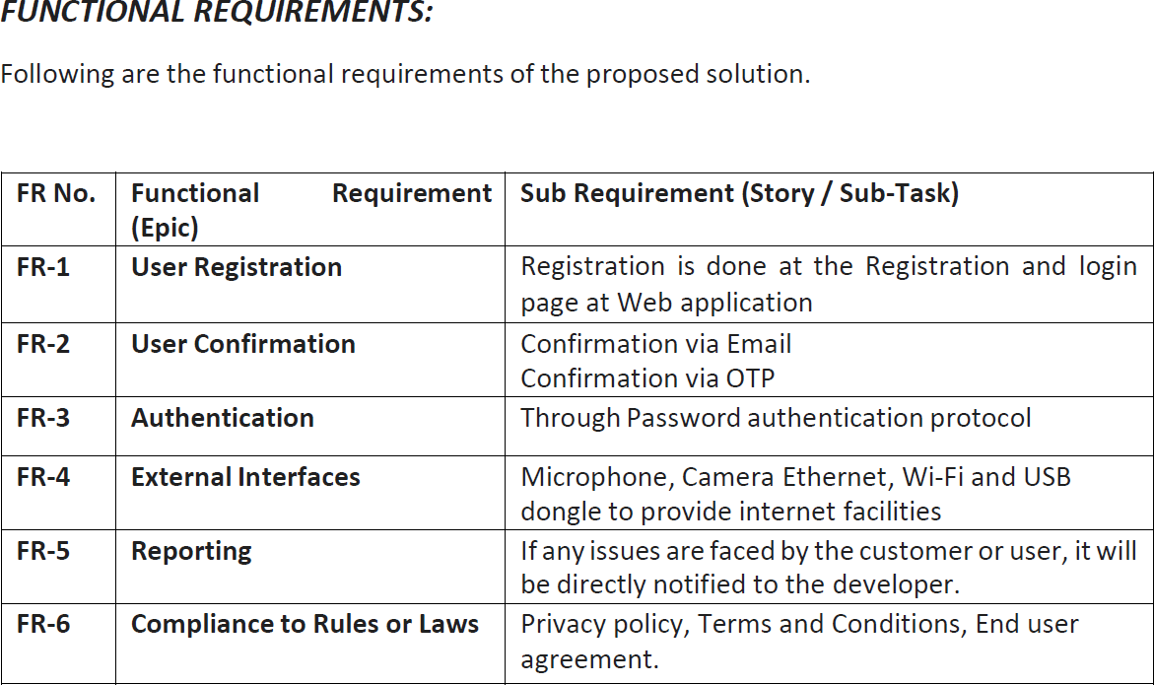

* 1. Non - Functional Requirements

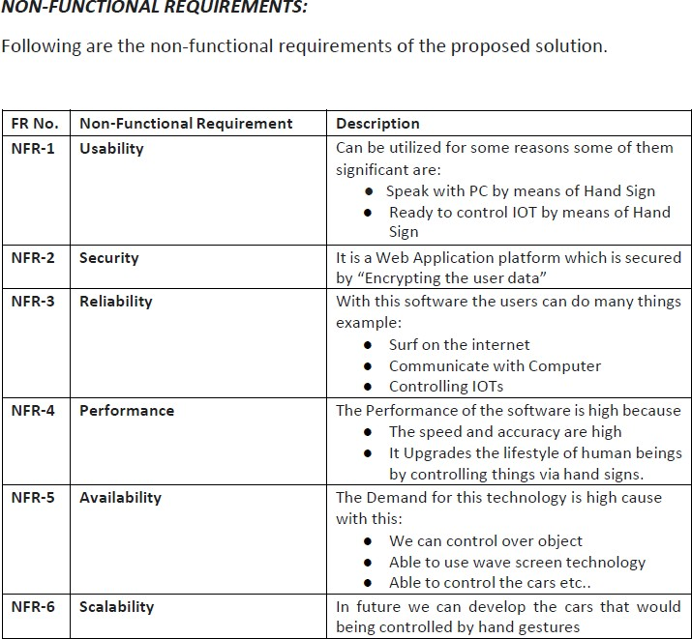

# PROJECT DESIGN :

* 1. Data Flow Diagrams

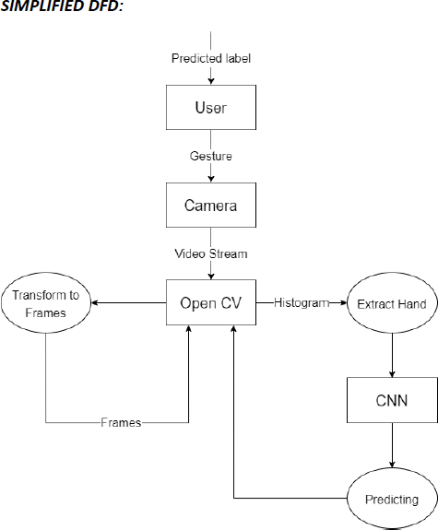

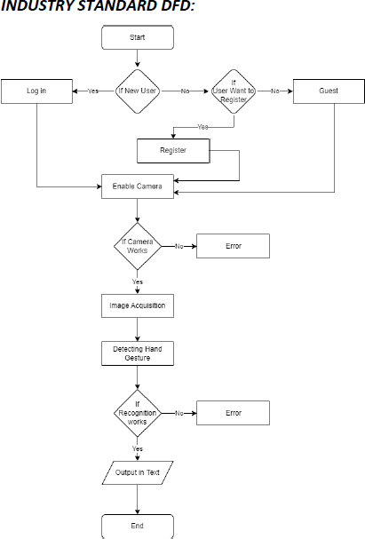

#### Solution & Technical Architecture

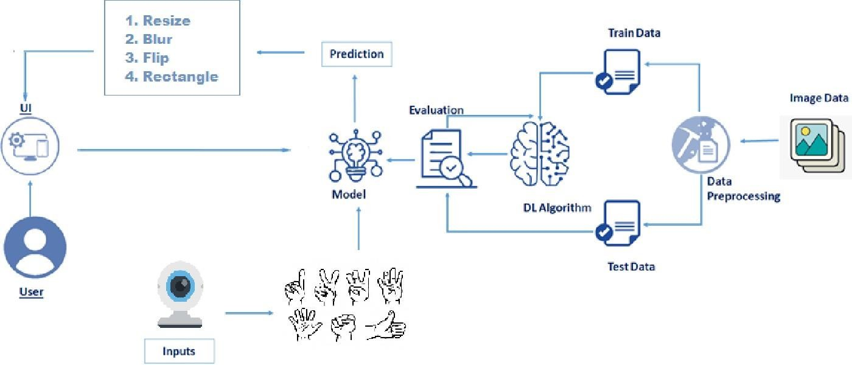

* 1. **User Stories**

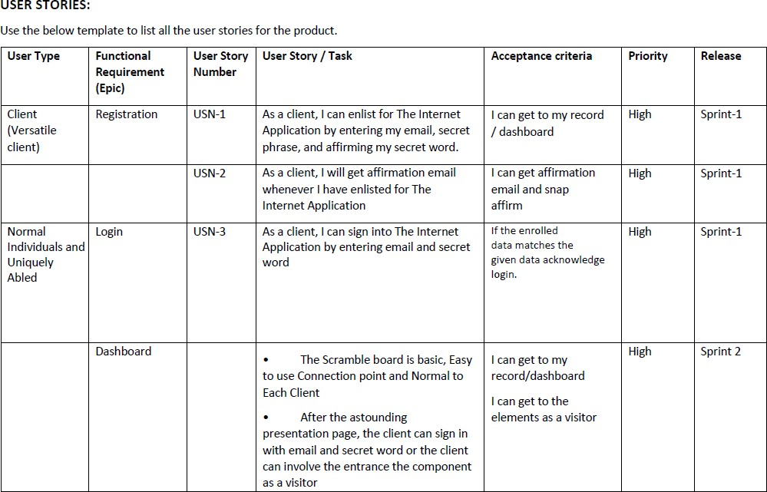

# PROJECT PLANNING & SCHEDULING

* 1. Sprint Planning & Estimation

**To accomplish the above task, you must complete the below activities andtasks:**

1. Collect the image data
2. Preprocess the collected images
3. Train the model
4. Test the model
5. Model is Generated
6. Application building using Html and CSS
7. Form for uploading the image
8. Python flask for connecting Model and Webpages

.

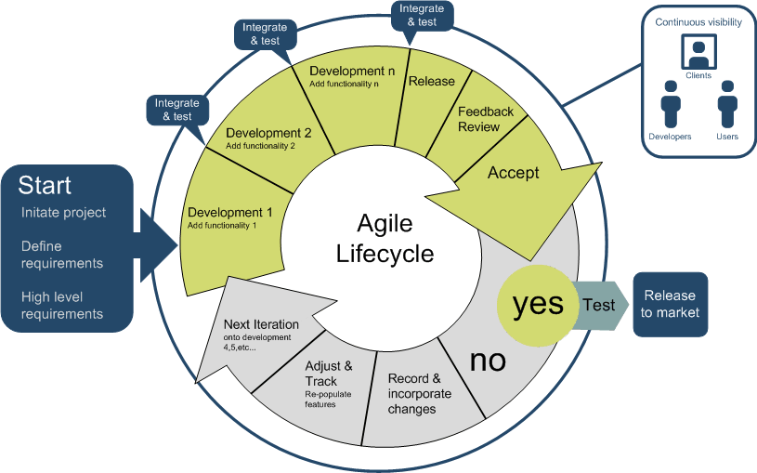

* 1. Sprint Delivery Schedule

**Product Backlog, Sprint Schedule, and Estimation**

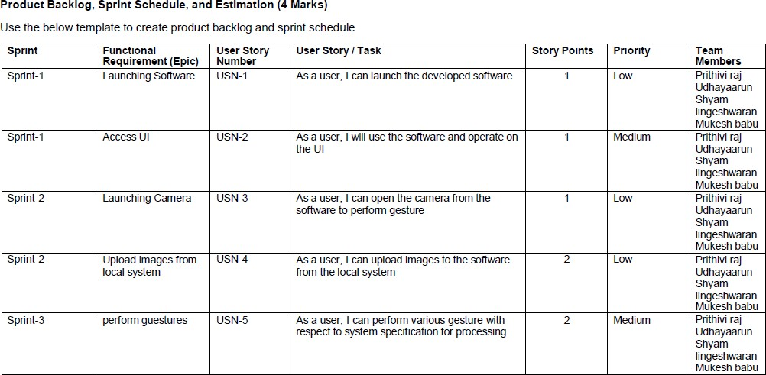

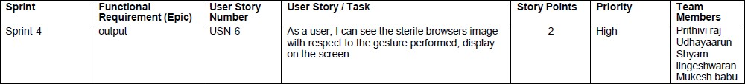

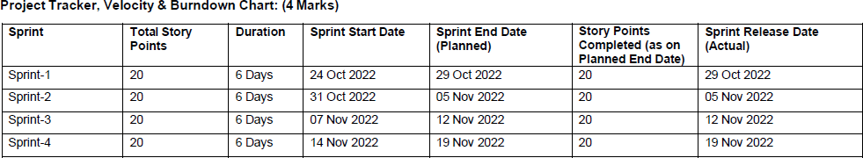

* 1. 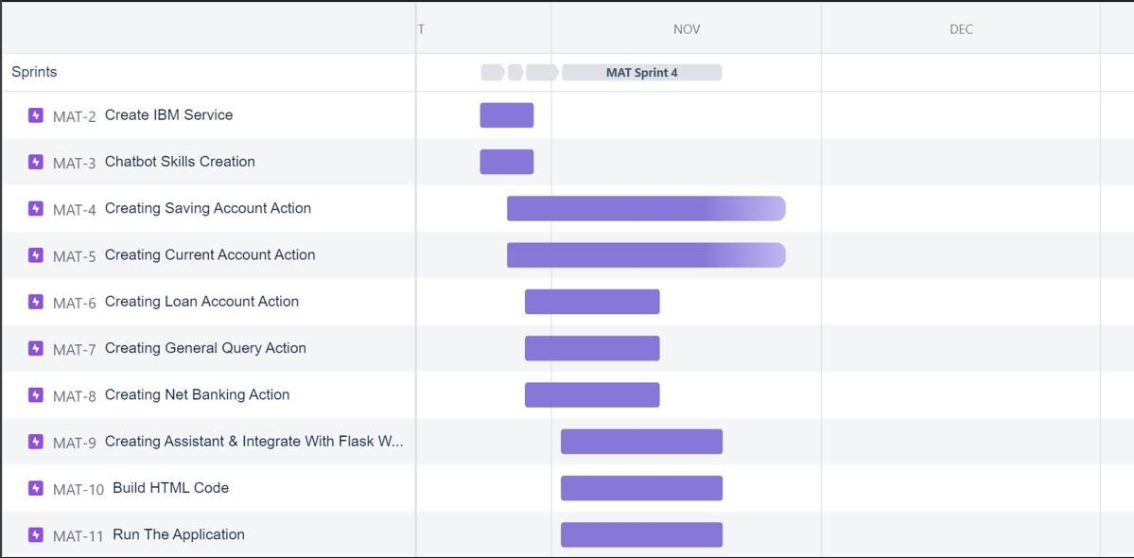**Reports from JIRA**

# CODING & SOLUTIONING :

## Feature 1

**1:IMAGE PREPROCESSING:**

**Import the ImagesDataGenerator Library:**



**Configure ImageDataGenerator Functionality To Trainset And Test set:**

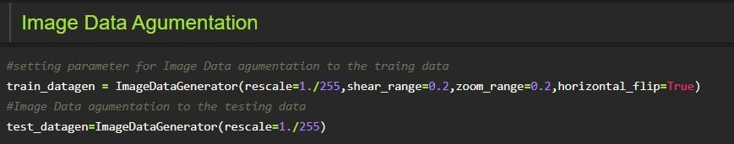

**Apply Image Data Generator Functionality To Trainset And Testset**

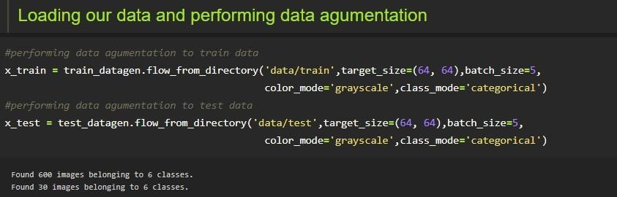

* 1. :MODEL BULIDING:

**Importing The Model Building Libraries**

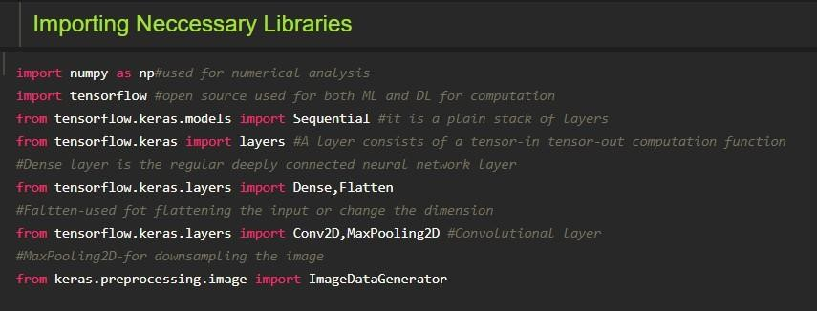

**Initializing The Model**



**Adding CNN Layers**

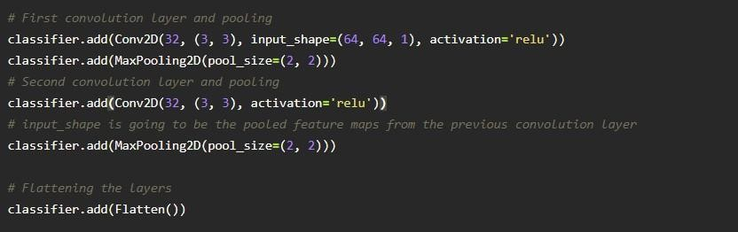

**Adding Dense Layers**

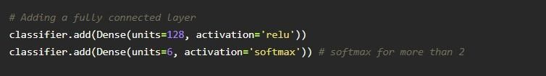

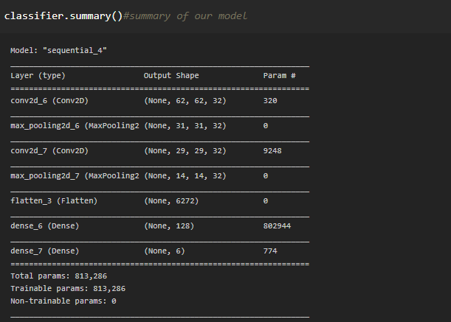



**Configure The Learning Process**

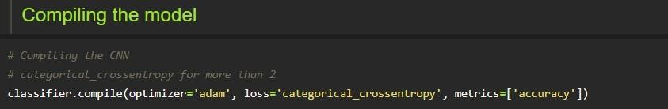

**Training Model**

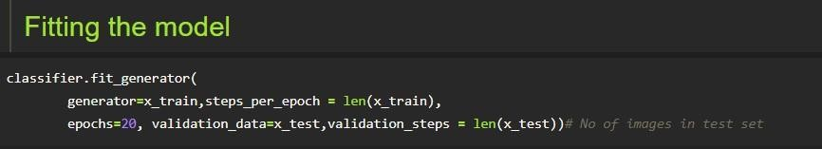

**Save the Model**

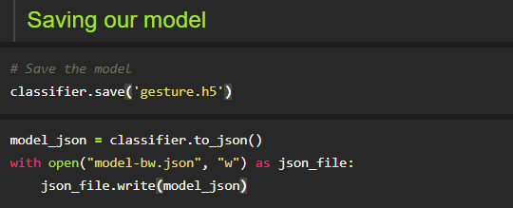

**Test the Model**

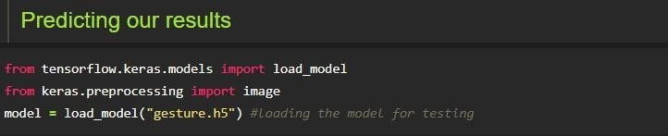

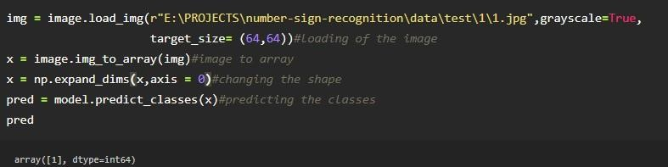

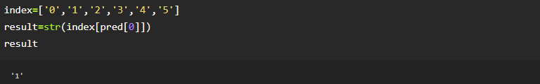

### Feature 2

* + - Let us build flask file ‘app.py’ which is a web framework written in python forserver-side scripting. Let’s see step by step procedure for building the backend application.
    - App starts running when “ name ” constructor is called in main.
    - render_template is used to return html file.
    - “GET” method is used to take input from the user.
    - “POST” method is used to display the output to the user.

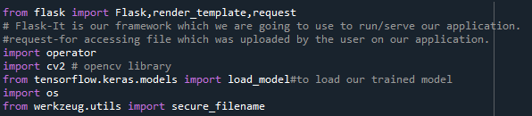1:Importing Libraries

#### 2:Creating our flask apllication and loading our model

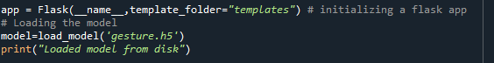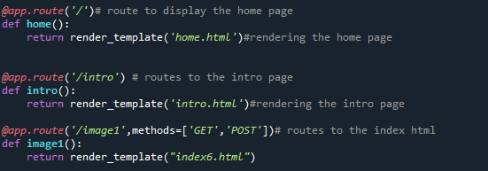



And the predict route is used for prediction and it contains all the codes which are used for predicting our results.

Firstly, inside launch function we are having the following things:

* + - 1. Getting our input and storing it
      2. Grab the frames from the web cam.
      3. Creating ROI
      4. Predicting our results
      5. Showcase the results with the help of[opencv](https://www.pyimagesearch.com/2018/07/19/opencv-tutorial-a-guide-to-learn-opencv/)
      6. Finally run the application
      7. Getting our input and storing it

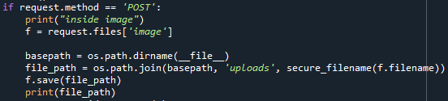Once the predict route is called, we will check whether the method is POST ornot if is POST then we will request the image files and with the help of os function we will be storing the image in the uploads folder in our local system.

* 1. Grab the frames from the web cam

Now when we run the code a web cam will be opening to take the gesture input so we will be capturing the frames of the gesture for predicting our results.

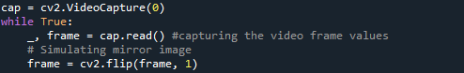

* 1. Creating ROI

A[region of interest (ROI)](https://towardsdatascience.com/extracting-regions-of-interest-from-images-dacfd05a41ba)is a portion of an image that you want to filter or operate on in some way. The toolbox supports a set of ROI objects that you can use to create ROIs of many shapes, such circles, ellipses, polygons, rectangles, and hand-drawn shapes. ... A common use of an ROI is to createa binary mask image.

So, we will be creating a ROI to mask our gesture.

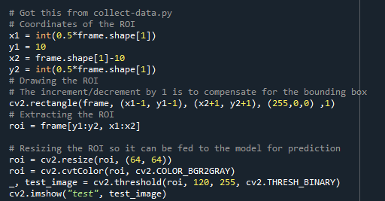

* + 1. Predicting our results

After placing the ROI and getting the frames from the web cam now its time to predict the gesture result using the model which we trained and stored it into a variable for the further operations.

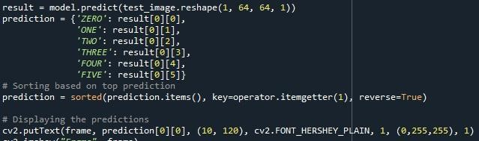

* + 1. Showcase the results with the help of opencv

Finally according to the result predicted with our model we will be performing certain operations like resize, blur , rotate etc.

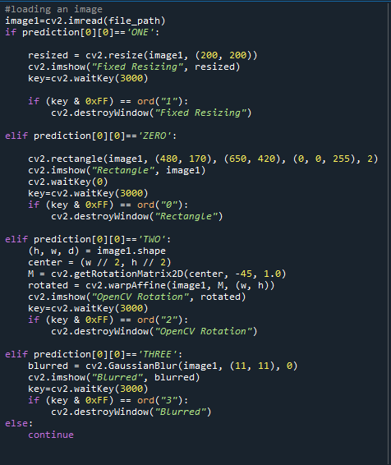

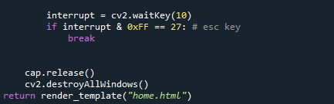

**RUN THE APPLICATION:**

At last, we will run our flask application

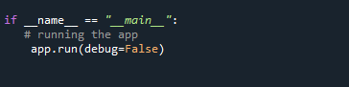

Run The app in local browser

* + 1. Open anaconda prompt from the start menu
    2. Navigate to the folder where your python script is.
    3. Now type “python app.py” command
    4. Navigate to the localhost where you can view your web page



Then it will run on localhost:5000

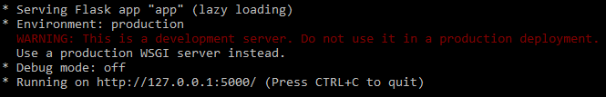

Navigate to the localhost (http://127.0.0.1:5000/)where you can view your web page.

# TESTING :

## Test Cases

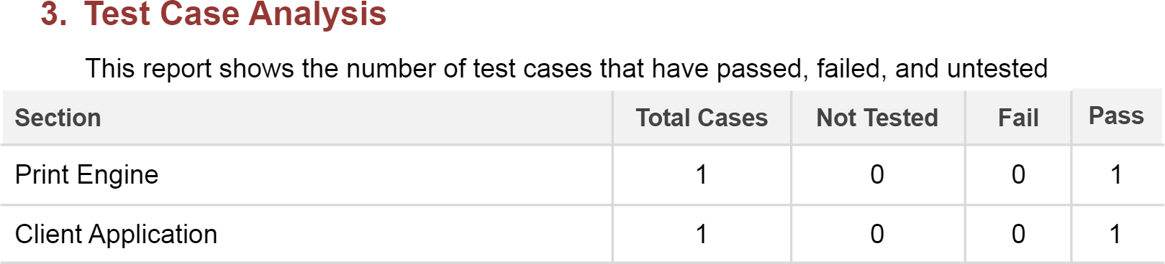

* 1. **User Acceptance Testing**

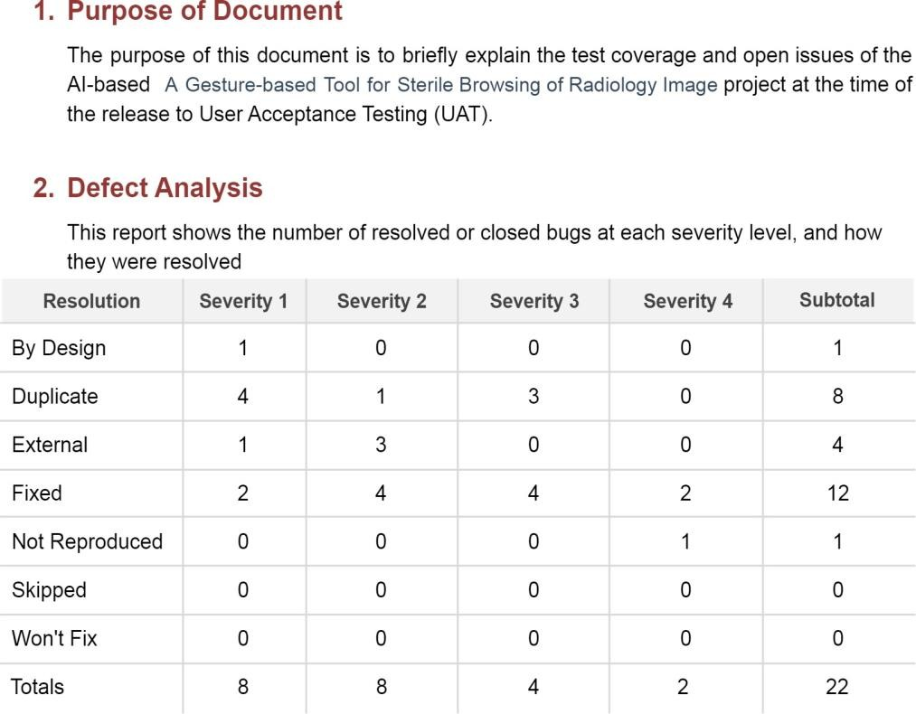

# RESULTS :

* 1. Performance Matrics

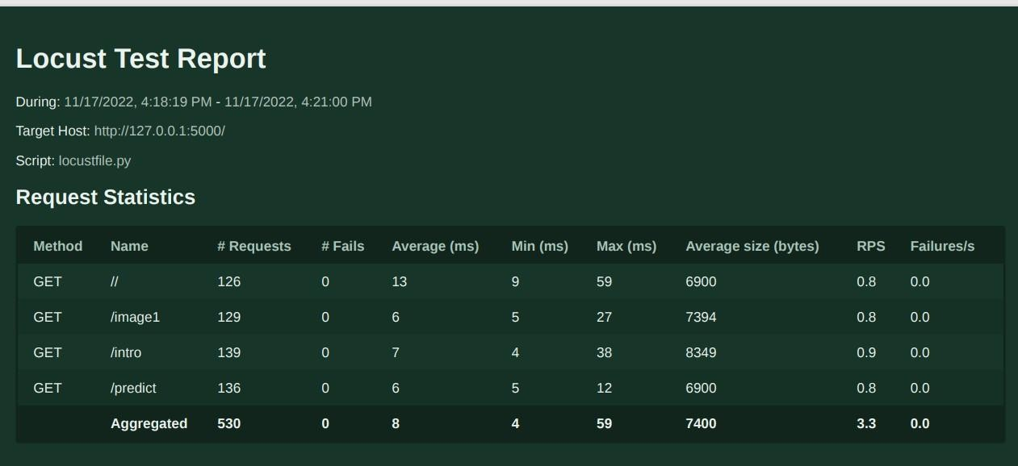

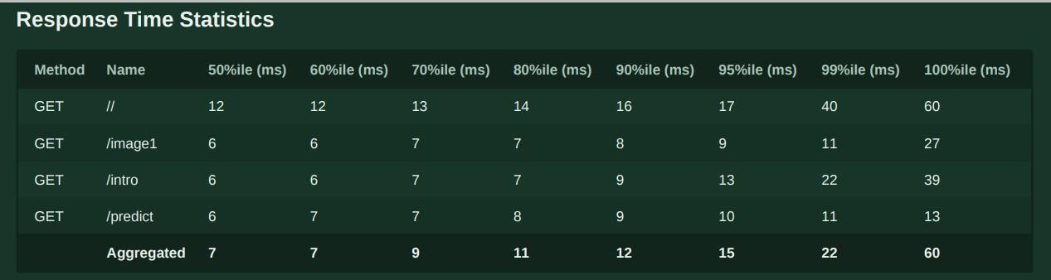

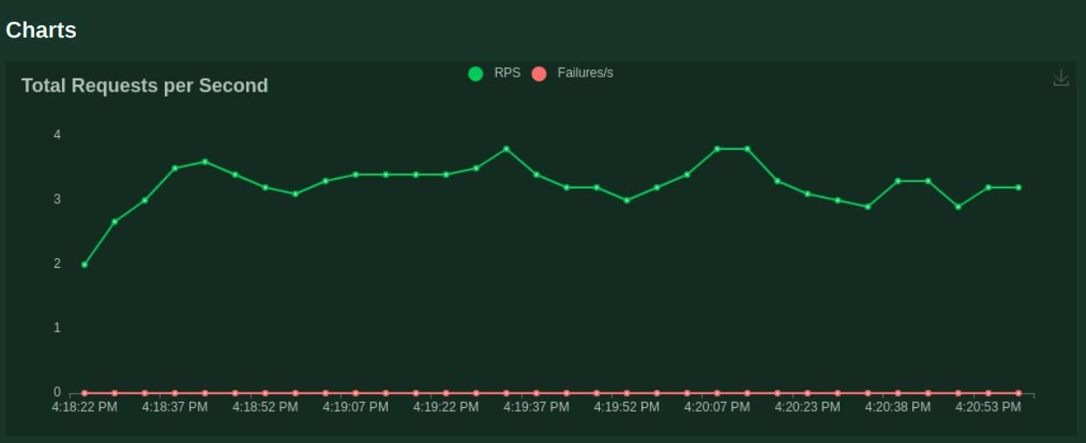

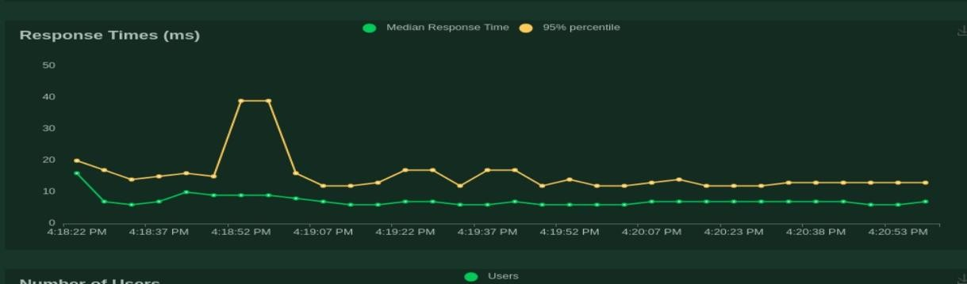

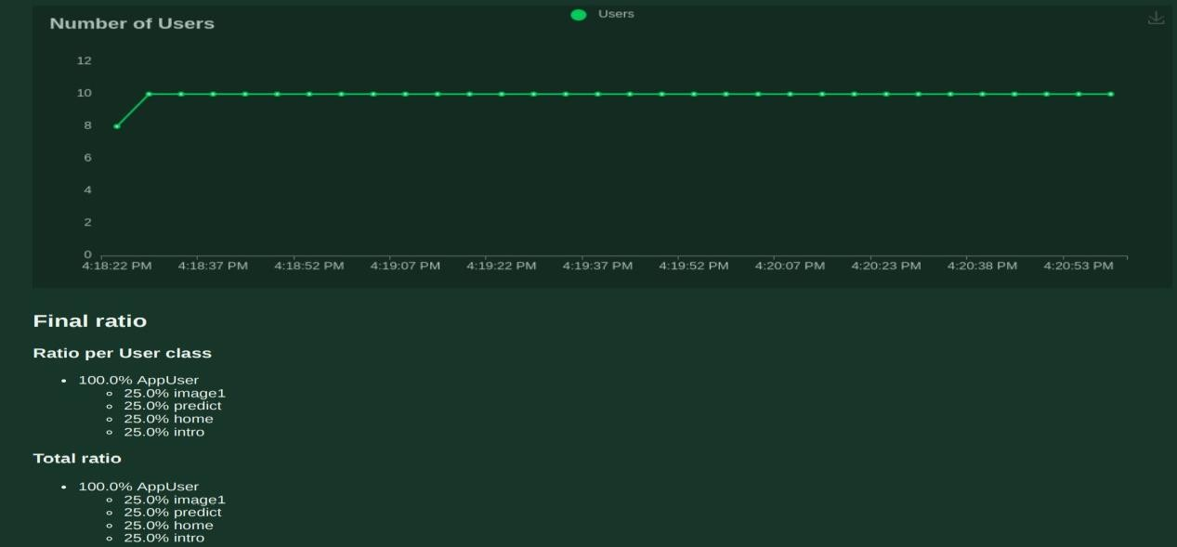

* 1. **.Output 1:Home Page:**

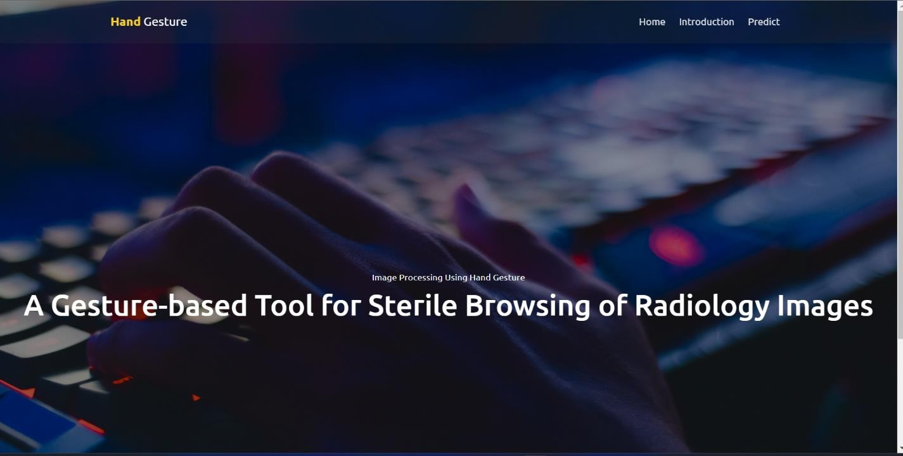

# 2:Introduction Page:

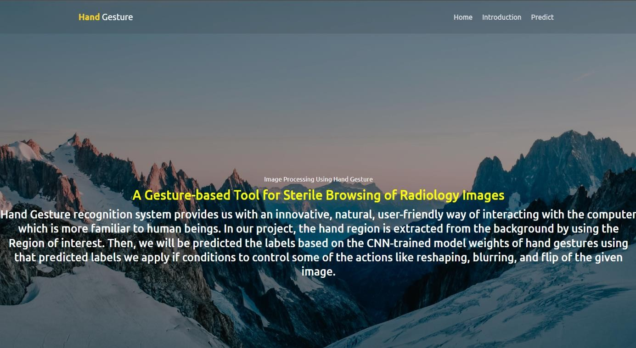

**3:Predict Page:**

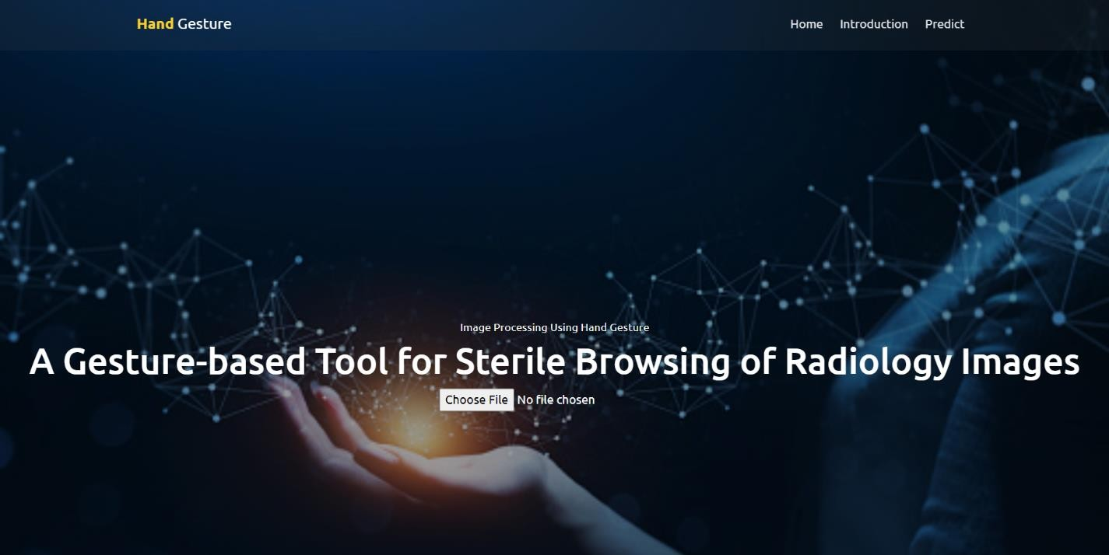

# :Upload Image:

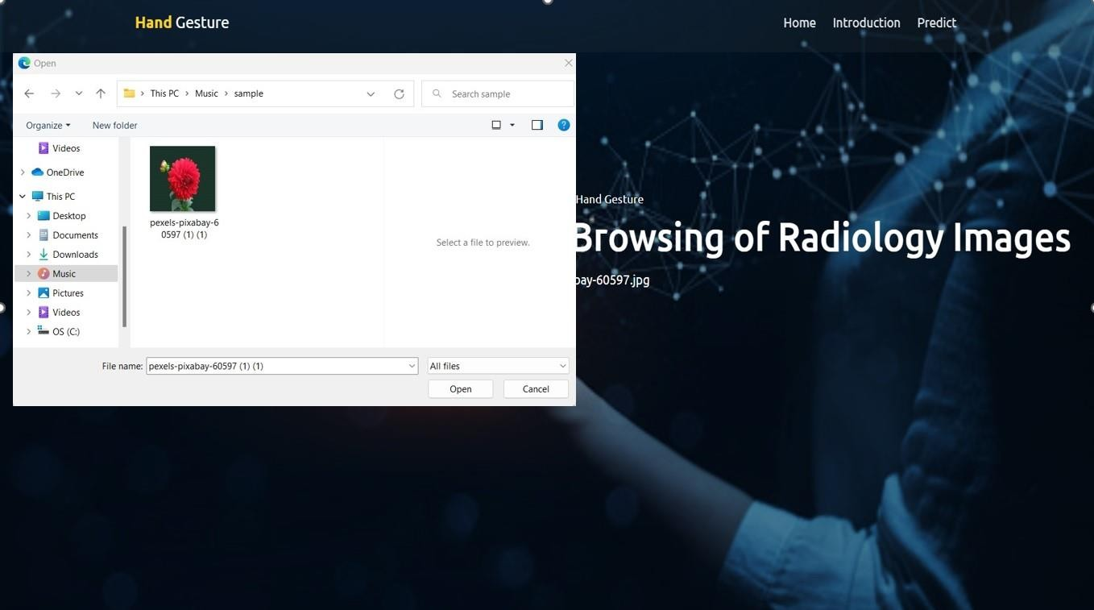

* 1. **:Image Uploaded:**

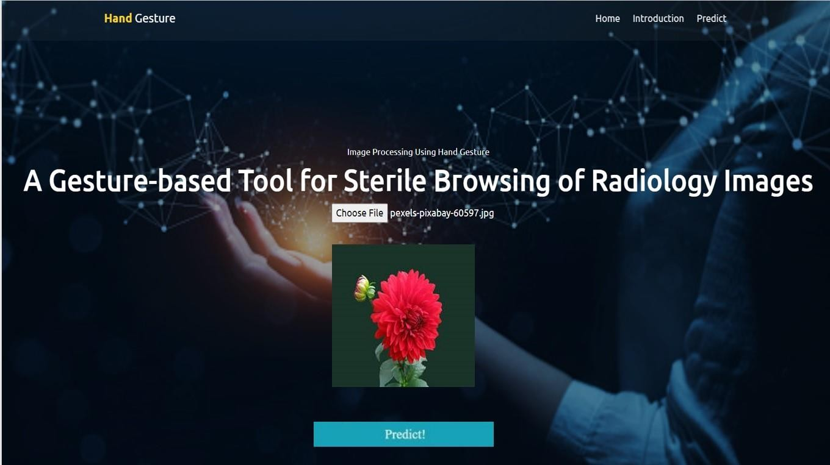

# PREDICT:

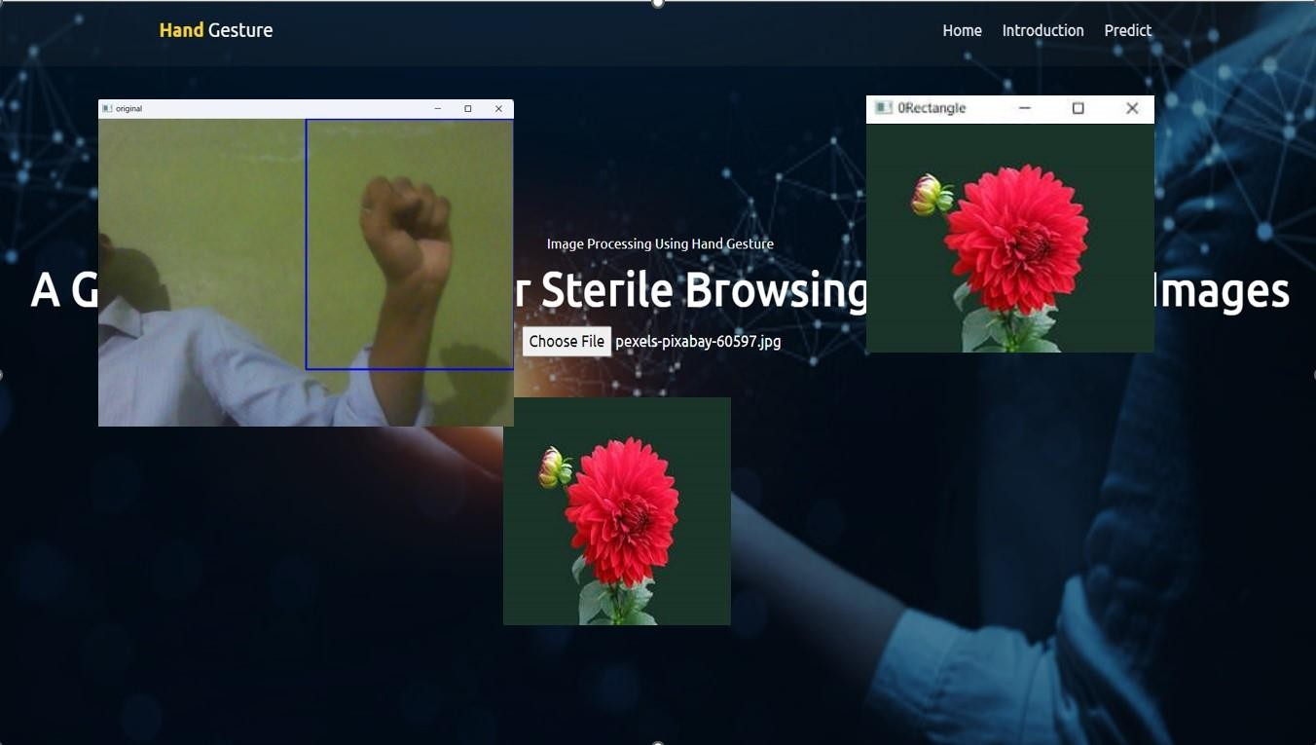

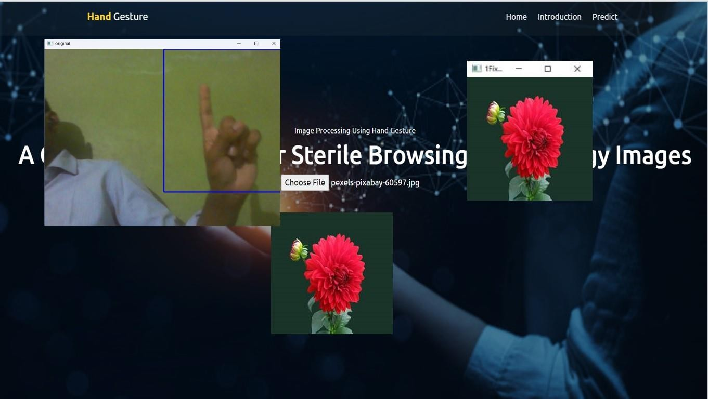

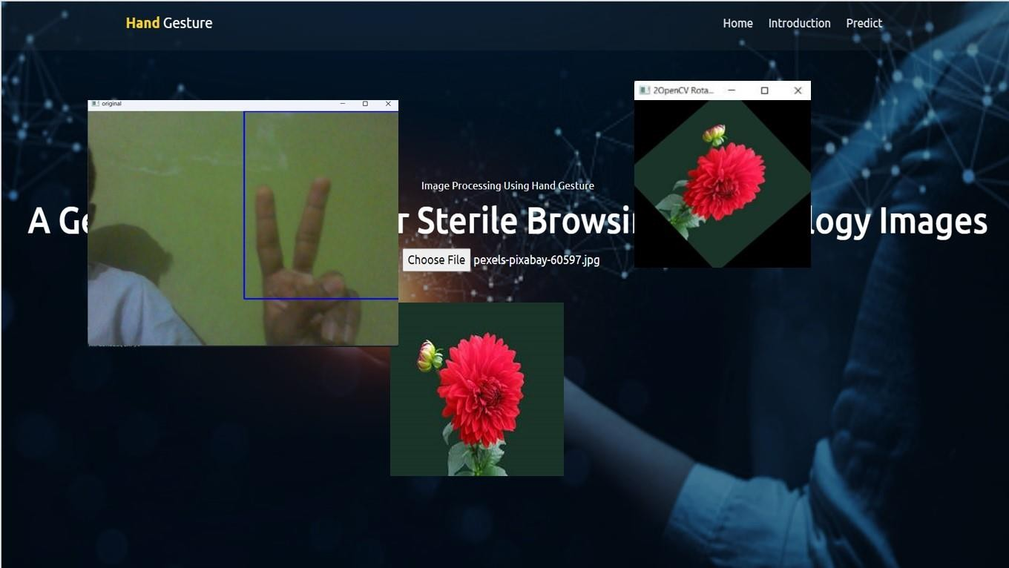

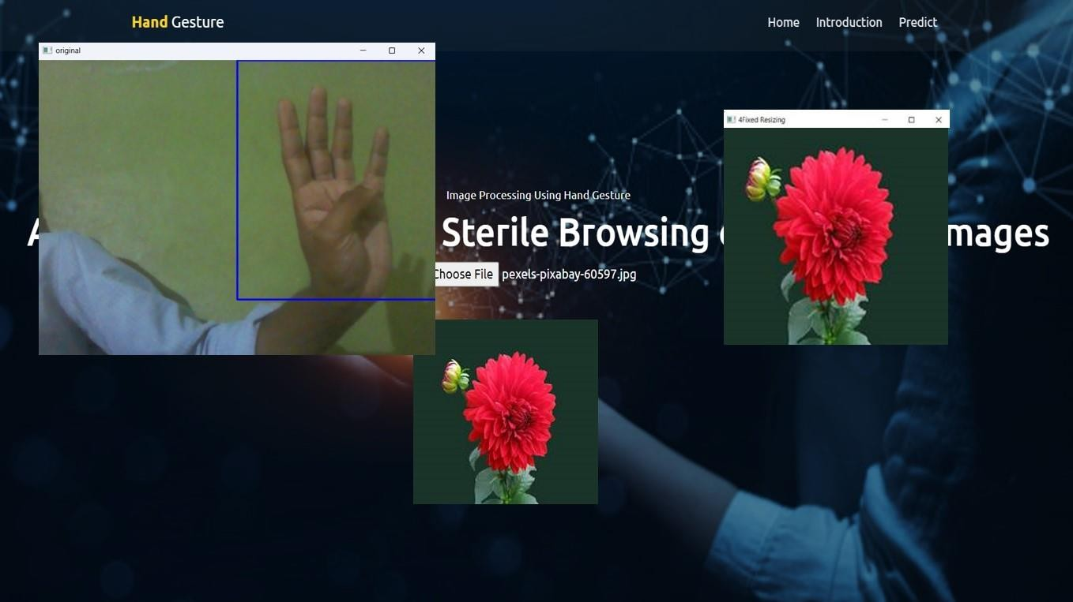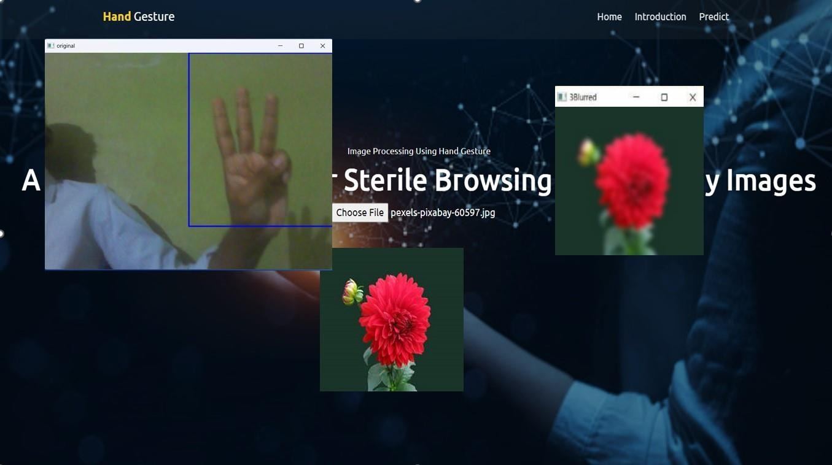

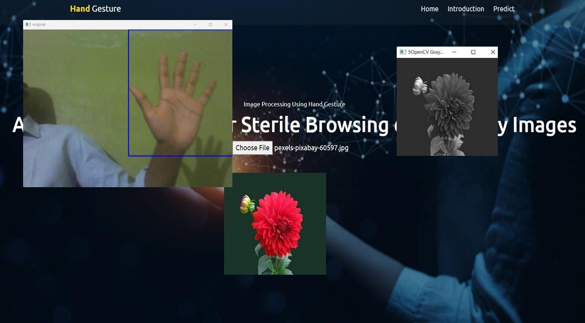

**4.Actions:**

➤ 0-Rectangle

➤ 1-Fixed Resizing(200,200)

➤ 2-OpenCV Rotation

➤ 3-Blurred

➤ 4-Fixed Resizing(400,400)

➤ 5-OpenCV Grey Scale

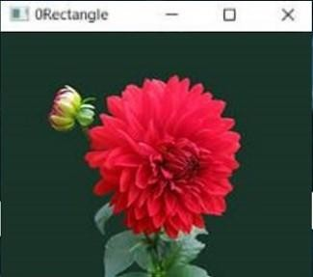



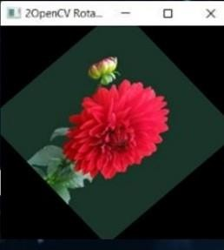

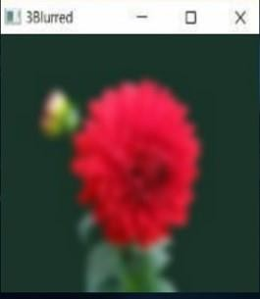



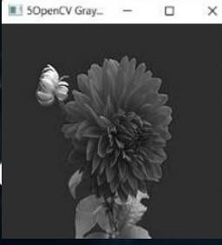

# ADVANTAGES & DISADVANTAGES:

### Advantages:

* + - Convenience — the framework permits the specialist to utilize his/her hands, their regular work instrument
    - Quick response — nonverbal guidelines by hand motion orders are natural and quick (practically speaking, the "Gestix" framework can deal with pictures and track hands at an edge pace of 150 Hz, in this way, answering the specialist's signal orders continuously)
    - An unhampered connection point — the proposed framework doesn't need the specialist to join a mouthpiece, use head-mounted (body-contact) detecting gadgets or to utilize foot pedals
    - Distance control — the hand motions can be performed up to 5 meters from the camera regardless be perceived precisely.
    - Exactness is high.
    - Memory Saving. [ because of cloud ]
    - An Unecumbered Connection point.
* Distance Control. Translation independent.

### Disadvantages:

* This sort of information additionally raises gives that are not pertinent with conventional information. On the client's side, these issues are to learn, to recollect and to execute motions precisely.
* The designer needs to give a framework that accurately perceives these motions. Freeman et al. commented that the perception of signals doesn't do the trick to learn them, as the eyewitness can't separate applicable and unessential developments.
* The instructing of multi-contact and mid-air motions is more troublesome than that of single-contact signals. On account of the last option, the hand act is immaterial - clients just have to follow a way accurately to play out an order.
* Picture Outlining isn't precise.
* Modest number of dataset.
* Wrong expectation in low light.
* Precision is less.
* Dataset isn't appropriate for continuous

# CONCLUSION :

In this venture , we proposed a thought for possible correspondence between hearing debilitated and normasl individual with the assistance of profound learning and AI approach. This is ever the encompassing test to foster a gesture based communication framework in information the assortment stays invariant of the unconstraint climate. This task can be ectended to the ongoing information.

Our strategy shows to have potential in handling this issue utilizing a straight forward camera as a premade dataset has been used.as been utilized, on the off chance that adequate significant preparation data is given, which can be constantly finished and included through the recently referenced process.

# FUTURE SCOPE :

The utilization of specialist PC communication gadgets in the activity room (OR) requires new

modalities that help clinical imaging control while permitting specialists' hands to stay clean, supporting their focal point of consideration, and giving quick reaction times.

.

# APPENDIX :

### SourceCode

1:home.html

<!DOCTYPE html>

<html lang="en">

<head>

<meta charset="utf-8">

<meta name="viewport" content="width=device-width, initial-scale=1, shrink-to- fit=no">

<meta name="description" content="Start your development with Creative Design landing page.">

<meta name="author" content="Devcrud">

<title>Hand Gesture Recognition</title>

<link rel="stylesheet" href="../static/vendors/themify-icons/css/themify-icons.css">

<link rel="stylesheet" href="../static/css/creative-design.css">

<style>

.header {

background: #efefef url(../static/imgs/3.jpg); background-size: cover;

background-position:center; background-repeat: no-repeat; text-align: center;

color: white; position: relative; height: 100%; position: relative;

}

</style>

</head>

<body data-spy="scroll" data-target=".navbar" data-offset="40" id="home">

<!-- Page Navbar -->

<nav id="scrollspy" class="navbar page-navbar navbar-light navbar-expand-md fixed-top" data-spy="affix" data-offset-top="20">

<div class="container">

<a class="navbar-brand" href="#"><strong class="text-primary">Hand</strong>

<span class="text-dark">Gesture</span></a>

<button class="navbar-toggler" type="button" data-toggle="collapse" data- target="#navbarSupportedContent" aria-controls="navbarSupportedContent" aria- expanded="false" aria-label="Toggle navigation">

<span class="navbar-toggler-icon"></span>

</button>

<div class="collapse navbar-collapse" id="navbarSupportedContent">

<ul class="navbar-nav ml-auto">

<li class="nav-item">

<a class="nav-link" href="home.html">Home</a>

</li>

<li class="nav-item">

<a class="nav-link" href="intro.html">Introduction</a>

</li>

<li class="nav-item">

<a class="nav-link" href="index6.html">Predict</a>

</li>

</ul>

</div>

</div>

</nav><!-- End of Page Navbar -->

<!-- Page Header -->

<header id="home" class="header">

<img src="../static/imgs/3.jpg" style="width:100%;height:100%;">

<div class="overlay"></div>

<div class="header-content">

<p>Image Processing Using Hand Gesture</p>

<h1>A Gesture-based Tool for Sterile Browsing of Radiology Images</h1>

</div>

</header><!-- End of Page Header -->

2:intro.html

<!DOCTYPE html>

<html lang="en">

<head>

<meta charset="utf-8">

<meta name="viewport" content="width=device-width, initial-scale=1, shrink-to-fit=no">

<meta name="description" content="Start your development with Creative Design landing page.">

<meta name="author" content="Devcrud">

<title>Hand Gesture Recognition</title>

<link rel="stylesheet" href="../static/vendors/themify-icons/css/themify- icons.css">

<link rel="stylesheet" href="../static/css/creative-design.css">

<style>

.header {

background: #efefef url(../static/imgs/1.jpg); background-size: cover;

background-position: center; background-repeat: no-repeat; text-align: center;

color: white; position: relative; height: 100%; position: relative;

}

</style>

</head>

<body data-spy="scroll" data-target=".navbar" data-offset="40" id="home">

<!-- Page Navbar -->

<nav id="scrollspy" class="navbar page-navbar navbar-light navbar- expand-md fixed-top" data-spy="affix" data-offset-top="20">

<div class="container">

<a class="navbar-brand" href="#"><strong class="text- primary">Hand</strong> <span class="text-dark">Gesture</span></a>

<button class="navbar-toggler" type="button" data- toggle="collapse" data-target="#navbarSupportedContent" aria- controls="navbarSupportedContent" aria-expanded="false" aria- label="Toggle navigation">

<span class="navbar-toggler-icon"></span>

</button>

<div class="collapse navbar-collapse" id="navbarSupportedContent">

<ul class="navbar-nav ml-auto">

<li class="nav-item">

<a class="nav-link" href="home.html">Home</a>

</li>

<li class="nav-item">

<a class="nav-link" href="intro.html">Introduction</a>

</li>

<li class="nav-item">

<a class="nav-link" href="index6.html">Predict</a>

</li>

</ul>

</div>

</div>

</nav><!-- End of Page Navbar -->

<!-- Page Header -->

<header id="home" class="header">

<img src="../static/imgs/1.jpg" style="width:100%;height:100%;">

<div class="overlay"></div>

<div class="header-content">

<p>Image Processing Using Hand Gesture</p>

<h1>A Gesture-based Tool for Sterile Browsing of Radiology Images</h1>

<input type="file" id="myFile" name="filename">

</div>

</header><!-- End of Page Header -->

3:index6.html

<html lang="en">

<head>

<meta charset="utf-8">

<meta http-equiv="X-UA-Compatible" content="IE=edge">

<meta name="viewport" content="width=device-width, initial-scale=1, shrink-to-fit=no">

<meta name="description" content="Start your development with Creative Design landing page.">

<meta name="author" content="Devcrud">

<title>Hand Gesture Recognition</title>

<link rel="stylesheet"

href="../static/vendors/themify-icons/css/themify-icons.css">

<link rel="stylesheet" href="../static/css/creative-design.css">

<link href="../static/css/creative-design.css/main.css"rel="stylesheet">

<link href="{{ url_for('static', filename='css/main.css') }}" rel="stylesheet">

<meta name="viewport" content="width=device-width, initial-scale=0.6">

<script src="https://ajax.googleapis.com/ajax/libs/jquery/3.3.1/jquery.min.js"></script>

<link href="https://cdn.bootcss.com/bootstrap/4.0.0/css/bootstrap.min.css" rel="stylesheet">

<script src="https://cdn.bootcss.com/popper.js/1.12.9/umd/popper.min.js"></script>

<script src="https://cdn.bootcss.com/jquery/3.3.1/jquery.min.js"></script>

<script src="https://cdn.bootcss.com/bootstrap/4.0.0/js/bootstrap.min.js"></script>

<link href="{{ url_for('static', filename='css/main.css') }}" rel="stylesheet">

<style>

.header {

background: #efefef url(../static/imgs/3.jpg); background-size: cover;

background-position: center center; background-repeat: no-repeat;

text-align: center; color: white; position: relative; height: 598px; position: relative;

}

.btncls{

position: relative; top: -133px;

left: 33px;

border-radius: 20px; height:30px;

font-size: 12px; border: none;

background-color: rgb(45, 45, 43);

color:rgb(252, 248, 248);

font-weight: 600;

}

#display-image{ width: 400px; height: 225px;

border: 3px solid rgb(45, 45, 43); border-radius:25px;

background-position: center; background-size: cover; position: relative;

top: -143px; left: 33px;

}

#image-input{

position: relative; top: -153px;

left: 33px;

border-radius: 20px;

background-color: rgb(45, 45, 43);

}

.topnav {

overflow: hidden; background-color: #056959;

}

.topnav-right a { float: left; color: black;

text-align: center; padding: 14px 16px; text-decoration: none; font-size: 18px;

}

.topnav-right a.active { background-color: #07201e; color: rgb(238, 226, 234);

}

.topnav-right a:hover {

background-color: rgb(181, 228, 236);

color: rgb(6, 27, 36);

}

.topnav-right { float: right;

padding-right:100px;

}

.button {

background-color: #091425;border: none;

color: black; padding: 15px 32px;text-align: center;

text-decoration: none; display: inline-block; font-size: 12px; border- radius: 16px;

}

.button:hover {

box-shadow: 0 12px 16px 0 rgba(0,0,0,0.24), 0 17px 50px 0 rgba(0,0,0,0.19);

}

form {border: 2px solid black; margin-left:400px;margin-right:400px;}

input[type=text], input[type=password] {width: 100%;

padding: 12px 20px; display: inline-block; margin-bottom:18px; border: 1px solid #ccc; box-sizing: border-box;

}

button {

background-color: #091425; color: black;

padding: 14px 20px; margin-bottom:10px; border: none; cursor: pointer; width: 19%;

border-radius:4px;

font-family:Montserrat;

}

button:hover { opacity: 0.8;

}

.cancelbtn { width: auto;

padding: 10px 18px; background-color: #f44336;

}

.imgcontainer { text-align: center;

margin: 24px 0 12px 0;

}

img.avatar { width: 30%;

border-radius: 50%;

}

.container { padding: 16px;

}

span.psw { float: right;

padding-top: 16px;

}

/* Change styles for span and cancel button on extra small screens */@media screen and (max-width: 300px) {

span.psw { display: block; float: none;

}

.cancelbtn { width: 100%;

}

}

.home{ margin:80px;

width: 84%; height: 500px; padding- top:10px;padding- left: 30px;

}

.login{ margin:80px;

box-sizing: content-box; width: 84%;

height: 420px; padding: 30px;

border: 10px solid rgb(12, 91, 94);

}

.left,.right{

box-sizing: content-box; height: 400px; margin:20px;

border: 10px solid rgb(12, 91, 94);

}

.mySlides {display: none;} img

{vertical-align: middle;}

/* Slideshow container */

.slideshow-container { max-width: 1000px; position: relative;

margin: auto;

}

/* Caption text */

.text {

color: #f2f2f2; font-size: 15px;

padding: 8px 12px; position: absolute; bottom: 8px;

width: 100%;

text-align: center;

}

/* The dots/bullets/indicators */

.dot {

height: 15px; width: 15px; margin: 0 2px;

background-color: #bbb; border-radius: 50%; display: inline-block;

transition: background-color 0.6s ease;

}

.active {

background-color: #267481;

}

/* Fading animation */

.fade {

-webkit-animation-name: fade;

-webkit-animation-duration: 1.5s; animation-name: fade; animation- duration: 1.5s;

}

@-webkit-keyframes fade {

from {opacity: .4}

to {opacity: 1}

}

@keyframes fade { from {opacity: .4}

to {opacity: 1}

}

/* On smaller screens, decrease text size */ @media only screen and (max-width: 300px) {

.text {font-size: 11px}

}

</style>

</head>

<body data-spy="scroll" data-target=".navbar" data-offset="40" id="home">

<!-- Page Navbar -->

<nav id="scrollspy" class="navbar page-navbar navbar-light navbar- expand-md fixed-top" data-spy="affix" data-offset-top="20">

<div class="container">

<a class="navbar-brand" href="#"><strong class="text-primary">Hand</strong> <span class="text-dark">Gesture</span></a>

<button class="navbar-toggler" type="button"

data-toggle="collapse" data-target="#navbarSupportedContent"aria- controls="navbarSupportedContent" aria-expanded="false" aria- label="Toggle navigation">

<span class="navbar-toggler-icon"></span>

</button>

<div class="collapse navbar-collapse" id="navbarSupportedContent">

<ul class="navbar-nav ml-auto">

<li class="nav-item">

<a class="nav-link" href="{{ url_for('home')}}"><u>Home</u></a>

</li>

<li class="nav-item">

<a class="nav-link" href="{{ url_for('intro')}}">Introduction</a>

</li>

<li class="nav-item">

<a class="nav-link" href="{{url_for('index6')}}">Predict</a>

</li>

</ul>

</div>

</div>

</nav><!-- End of Page Navbar -->

<!-- Page Header -->

<header id="home" class="header">

<img src="../static/imgs/11.png" style="width:1000px;height:600px;">

<div class="overlay"></div>

<div class="header-content"><br><br><br><br><br><br><br>

<p>Image Processing Using Hand Gesture</p>

<h1>A Gesture-based Tool for Sterile Browsing of Radiology Images</h1>

<div>

<h4>Upload Image Here</h4>

<form action = "http://localhost:5000/" id="upload-file" method="post" enctype="multipart/form-data">

<label for="imageUpload" class="upload-label">Choose...

</label>

<input type="file" name="image" id="imageUpload" accept=".png,

.jpg, .jpeg,.pdf">

</form>

<center>

<div class="image-section" style="display:none;">

<div class="img-preview">

<div id="imagePreview">

</div>

</div>

<div>

<button type="button" color="#f35ac5" class="btn btn-info btn-lg" id="btn-predict">Predict!</button>

</div>

</div>

<div class="loader" style="display:none;"></div>

</center>

</div>

</div1>

<footer>

<script src="{{ url_for('static', filename='js/main.js') }}" type="text/javascript"></script>

</footer>

</html>

1. GitHub & Project Demo Link

GITHUB:

**https://github.com/IBM-EPBL/IBM-Project-36777-1660297789**

PROJECT DEMO LINK:

#### https://drive.google.com/file/d/19PN7frnDjFJdJn7oU0XnachwNo-M-Fte/view?usp=share_link